19N820 - PROJECT WORK - II

A ZERO TRUST FRAMEWORK WITH HYBRID ACCESS CONTROL, RISK-AWARE DECISIONS, AND BLOCKCHAIN AUDITING

AJAY P (22N205)
ASHWIN KUMAR R S (22N209)
GANESH KUMAR A (22N217)
RAKSHANA V (22N241)
SRIVATSAN R (22N256)

Dissertation submitted in partial fulfillment of the requirements for the degree of

BACHELOR OF ENGINEERING

Branch: COMPUTER SCIENCE AND ENGINEERING
(Artificial Intelligence and Machine Learning)
of Anna University


April 2026

DEPARTMENT OF COMPUTER SCIENCE AND ENGINEERING
PSG COLLEGE OF TECHNOLOGY
(Autonomous Institution)
PSG COLLEGE OF TECHNOLOGY
(Autonomous Institution)
COIMBATORE – 641004
A ZERO TRUST FRAMEWORK WITH HYBRID ACCESS CONTROL, RISK-AWARE DECISIONS, AND BLOCKCHAIN AUDITING

Bona fide record of work done by

AJAY P (22N205)
ASHWIN KUMAR R S (22N209)
GANESH KUMAR A (22N217)
RAKSHANA V (22N241)
SRIVATSAN R (22N256)
Dissertation submitted in partial fulfillment of the requirements for the degree of

BACHELOR OF ENGINEERING

Branch: COMPUTER SCIENCE AND ENGINEERING
(Artificial Intelligence and Machine Learning)

of Anna University
April 2026
…………………………. ………………………….
Dr. S. Vijayalakshmi Dr. G. Sudha Sadhasivam
Faculty guide Head of the Department
______________________________________________________________________
Certified that the candidate was examined in the viva-voce examination held on

…………………………. ………………………….
(Internal Examiner) (Panel Members)

CERTIFICATE
Certified that this report titled “A ZERO TRUST SECURITY FRAMEWORK", for the PROJECT WORK 2 (19Z820) is a bonafide work of Ajay P (22N205), Ashwin Kumar R S (22N209), Ganesh Kumar A (22N217), Rakshana V (22N241), Srivatsan R (22N256) who have carried out the work under my supervision for the partial fulfillment of the requirements for the award of the degree of Bachelor of Engineering in Computer Science & Engineering. Certified further that to the best of my knowledge and belief, the work reported herein does not form part of any other thesis or dissertation on the basis of which a degree or an award was conferred on an earlier occasion.
Ajay P (22N205)
Ashwin Kumar R S (22N209)
Ganesh Kumar A (22N217)
Rakshana V (22N241)
Srivatsan R (22N256)

Place: Coimbatore Dr. S. Vijayalakshmi
Date: 15.04.2026 FACULTY GUIDE Department of Computer Science and Engineering
PSG College of Technology
Coimbatore – 641004

COUNTERSIGNED

HEAD
Department of Computer Science and Engineering
PSG College of Technology
Coimbatore – 641004

CONTENTS

CHAPTER Page No.

ACKNOWLEDGEMENT

The Final year project work - II had paved the way for personal development and creativity as proud volunteers with a sense of achievement and ready to take up projects having a social impact and creating digital awareness. We feel privileged to be associated with such a curriculum in PSG College of Technology.
We are extremely grateful to our Principal Dr. K. Prakasan for facilitating and extending untiring support in successful completion of the project. We are extremely glad to extend our gratitude to Dr. G. Sudha Sadhasivam, Head of the department, and Programme Co-ordinator Dr. G. R. Karpagam, Professor, for offering us this opportunity which has made us strengthen our soft skills, leadership qualities and team spirit. We extend our thanks to Department Placement Co-ordinator Dr.K.Sathiya Priya, Associate Professor, who has been the pillar of support.
Our sincere thanks are due to Dr. S. Vijayalakshmi, Assistant Professor(SG), Computer Science Engineering Department, project guide whose valuable guidance and continuous encouragement throughout the course made it possible to complete this dissertation work well in advance.
We would like to place our sincere thanks to our Tutor Dr. D. Indumathi , Associate Professor, for her guidance in our project work and would also like to thank our Panel members who have spent their valuable time to aid us for coming out with the good project.
We would like to place our sincere thanks to Lab Technical Staff & Friends for offering us this opportunity and they have rendered their utmost support and made us aware of social issues that gave us the vision to have societal commitment leading to community service

SYNOPSIS

The conventional enterprise security systems are based on perimeter-based models whereby after authentication, users and devices within the network are implicitly trusted. Nevertheless, as the number of cyber threats like insider attacks, credential theft, and compromised devices are on the rise, these models are not adequate anymore. The current security architectures involve constant verification and a stringent access control mechanism to make sure that unauthorized users cannot access important resources.
Zero Trust Architecture (ZTA) is a new security strategy that does not presume trust and insists on constant validation of all access requests, no matter where they occur on the network. Unlike depending on network boundaries to create trust, Zero Trust requires identity verification, contextual validation, and policy-based authorization prior to authorization.
The proposed project includes a Zero Trust security architecture with Role-Based Access Control (RBAC) and Attribute-Based Access Control (ABAC) and dynamic scoring of risks, blockchain-based audit logging, and privacy-preserving authentication based on the concept of Zero Knowledge Proof (ZKP). The system is deployed as a fully stacked web application and simulates access control at the enterprise level and illustrates how the current security principles could be used to improve the protection of the system.

LIST OF IMAGES AND TABLES

CHAPTER 1

INTRODUCTION

This section lays the groundwork for the work and provides an overview of the project's history.

1.1 Problem Description
Conventional security designs tend to provide unspoken trust to users after authentication within the network boundary. The method poses security risks particularly when attackers gain access to legitimate credentials or when rogue insiders abuse the privileges.The current systems are also not transparent on audit logs and can reveal sensitive authentication information. Thus, it is necessary to have a security framework that imposes constant verification, fine-grained access control, secure authentication, and audit logging that cannot be tampered with.

1.2 Motivation
The rationale behind this project is that there is a necessity to adopt a modern Zero Trust security architecture that does not assume implicit trust and imposes strict verification on each access request. The system combines RBAC, ABAC, risk-based analysis, blockchain-based audit logging, and privacy-preserving authentication to illustrate the potential of advanced security methods to collaborate to deliver secure, transparent, and reliable access control.

1.3 Objectives
- The main objectives of this project are:
- To build and deploy a Zero Trust security infrastructure to control access securely.
- To incorporate Role-Based Access Control (RBAC) to coarse-grained authorization.
- To apply the concept of Attribute-Based Access Control (ABAC) to make context-aware fine-grained access decisions.
- To create a risk scoring system which can dynamically assess access requests.
- To use Zero Knowledge Proof (ZKP) ideas to introduce privacy-preserving authentication.

CHAPTER 2

LITERATURE SURVEY
Zero Trust security model focuses on the principle of never trust, always verify, according to which all access requests are continuously verified and authorized irrespective of the location of the user in the network. In this strategy, there is no implicit trust in the internal networks and this is replaced by policy decision points and policy enforcement points that implement stringent access policies. Nevertheless, most of the current frameworks primarily emphasize conceptual architecture as compared to the real implementation. [1]
The other method of enterprise security eliminates the traditional network perimeter and leaves identity-conscious access controls. This model is characterised by access based on the user identity and device security status instead of network location. Although this method is very effective in enhancing the security of the enterprise and allows secure access to it remotely, the implementation of such systems in large organizations may complicate the functioning. [2]
Subsequent studies have investigated the implementation of Zero Trust architectures into practice. These systems use identity-based access control systems that constantly checks users prior to accessing the resources. Despite the useful practical insights that are contained in these implementations, most of them are closely linked to certain enterprise infrastructures and might not be readily applicable to other settings. [3]
Best practices on implementing Zero Trust architectures have also been suggested in the effort to assist organizations to move out of the conventional security frameworks. These models bring about policy engines and framework architectures on how to implement secure access control mechanisms. Nevertheless, not all of these methods have dynamic risk scoring capabilities, which are significant to assess contextual security conditions. [4]
Attribute-Based Access Control (ABAC) is a popular access-control model that has been extensively researched as a fine-grained access control model that considers various attributes like user roles, environment conditions, and device characteristics prior to access. This can give context sensitive authorization decisions, but can add complexity to policy definition and management. [5]
Recent works have also suggested risk-based access control mechanisms which compute dynamic risk scores of every access request. These frameworks work out the contextual parameters, including the trust level of the device, the time of access, and the frequency of requests to decide whether the access should be granted. This strategy is effective in enhancing adaptive security, however, the calculation of the right risk levels can be problematic. [6]
The use of the blockchain technology as a means to provide secure audit logging in access control systems has been investigated. Systems can have tamper-proof and transparent audit trails by storing access logs in a blockchain ledger. Nevertheless, logging schemes based on blockchain can create a performance burden because of the distributed nature of the technology. [7]
Part of the studies has been done on the immutable logging systems that are based on blockchain to improve the integrity of the security logs. These systems also guarantee that an access event cannot be altered or removed once registered thus enhancing accountability and transparency in security monitoring. However, scaling and storage needs are still critical issues. [8]
It has also suggested decentralized auditing mechanisms to check security events within the distributed systems. With blockchain consensus mechanisms, these methods offer an open-ended validation of the access logs. Nevertheless, blockchain consensus protocols can be quite complex, which can add additional overhead to the system. [9]
Zero Knowledge Proofs (ZKP) have been examined as a privacy-preserving method of authentication wherein a user is able to authenticate themselves without disclosing any sensitive credentials. Such cryptographic methods make it possible to authenticate safely and preserve user privacy but usually come at a high price of computation. [10]
Zero Trust environments have also suggested continuous authentication mechanisms to make sure that users are trustworthy during their sessions. These systems constantly track what the user is doing and when to help identify possible insider threats. Nevertheless, they can be very complicated to use and may demand a lot of user behavior profiling. [11]
Other authentication systems rely on machine learning and behavioral analytics to constantly authenticate users according to their interaction patterns. Although they play an important role in enhancing security, they create reliance on machine learning models and big data to detect them. [12]

CHAPTER 3

SYSTEM REQUIREMENTS

The following are the hardware and software requirements for the implementation.

3.1 Hardware Requirements
- Processor: Intel Core i3 or higher
- RAM: Minimum 4 GB (8 GB recommended)
- Storage: At least 20 GB free disk space
- Network: Internet connectivity for development tools and package installation
- System Type: 64-bit computer system

3.2 Software Requirements
- Operating System: Windows 10 / Linux / macOS
- Frontend: React.js, HTML, CSS, JavaScript
- Backend: Node.js with Express.js
- Database: MongoDB / MongoDB Atlas
- Blockchain Framework: Local or simulated blockchain environment
- Development Tools: Visual Studio Code
- Version Control: Git and GitHub
- Web Browser: Google Chrome / Microsoft Edge / Mozilla Firefox
- Package Manager: npm (Node Package Manager)

CHAPTER 4

SYSTEM DESIGN

System Design describes how our Zero Trust Framework is designed. It shows how different modules, such as RBAC, ABAC, and Blockchain, were integrated to enhance security.

4.1 System Flow
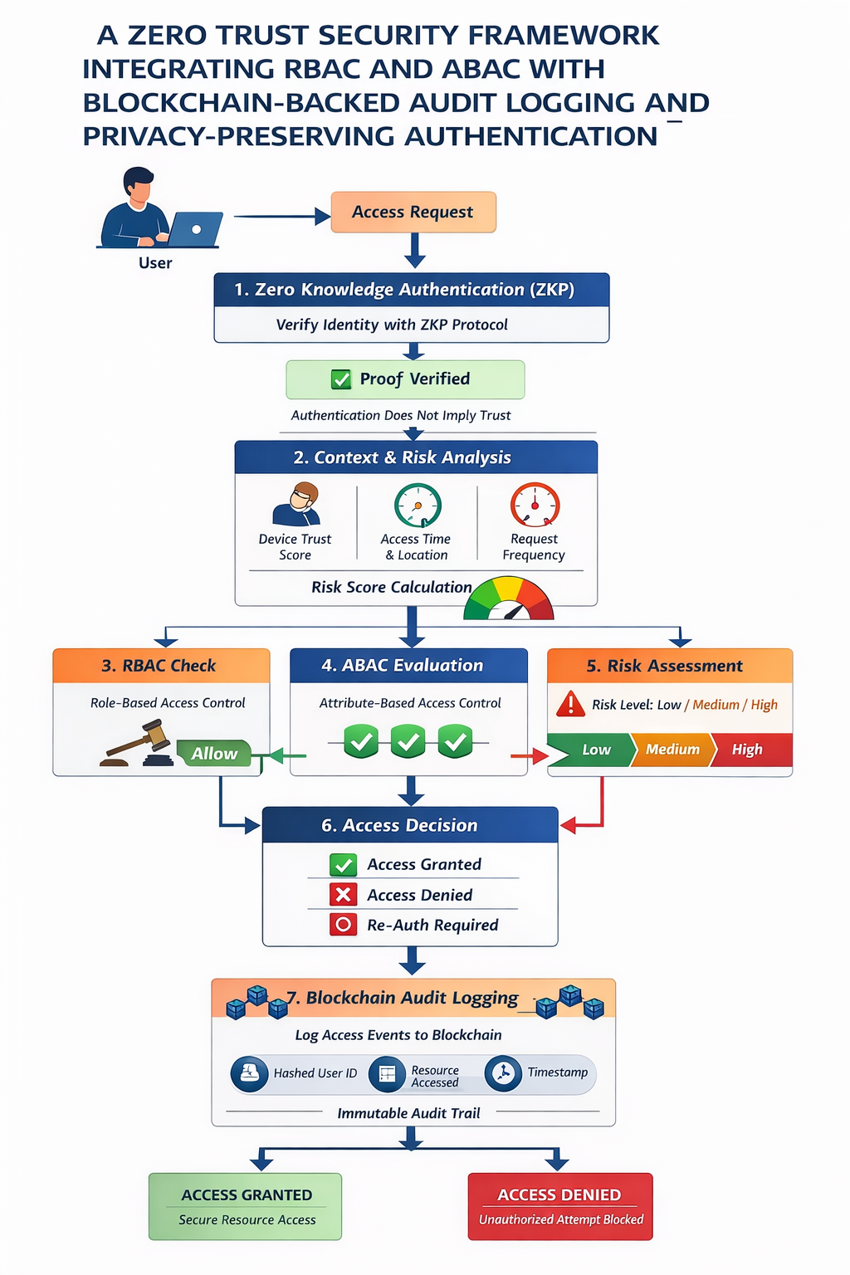
Fig 4.1: Proposed System design

4.1.1. System Input
The system triggers the access evaluation process by gathering the input parameters of the user provided and contextual parameters. These inputs are necessary to determine who is making the request and what the request entails as well as the context within which the access request is being made.
The major inputs are the user credentials, the username and password are safely managed in hashed format to maintain confidentiality. Besides authentication information, the system records information about the access request, including the requested resource (dashboards or records).
Role-based information is included as well, based on the assigned role to a user in the system, e.g. an administrator, employee, or viewer. In addition, a user attribute set is taken into consideration, which involves the department of the user, the type of device in use (trusted or untrusted), and the access point (office network or remote access).
In order to improve security by considering contextual awareness, other parameters are also considered such as time of access, and the level of sensitivity of the requested resource.
All these inputs together present a complete picture of who the user is, what they want and the environment they are working in, the basis of secure and dynamic access control decisions in the system.
4.1.2. System Processing
After receiving the input, the system verifies the access request by going through several consecutive verification steps in line with the principles of Zero Trust Architecture to make sure that there is secure and context-oriented decision-making at each step.
Step 1: Authentication (ZKP-Inspired): User authentication is the first step, in which the identity is authenticated by hashed credentials. To achieve confidentiality and secure verification, a challenge response mechanism is used to validate the user and without showing any raw credentials.
Step 2: RBAC Verification: Role-Based Access Control is performed by the system to determine whether the user is allowed access to the requested resource based on their assigned role. This is the first authorization filter that will permit valid roles to pass through.
Step 3: ABAC Evaluation: ABAC is used to evaluate contextual parameters like department, device trust level and access location to implement fine-grained and context-aware access control.
Step 4: Risk Scoring Engine: A rule based engine determines a risk score, based on the use of factors like untrusted device usage, remote access, abnormal access time, and resource sensitivity to give a numerical depiction of possible risk.
Step 5: Decision Engine: The decision engine takes the output of RBAC, ABAC and the Risk Score to form the final decision. Access is provided under the condition of all the requirements are met and the risk is minimal and conditional upon the discovery of moderate risk and denied in case of failure in verification or high risk.
Step 6: Blockchain Audit Logging: Each access decision is stored in a blockchain-based log with hashed user ID, resource, risk score, decision and timestamp. Cryptographic hashing is used to ensure that each entry is connected to the others, making system activities traceable, accountable and immutable.
4.1.3. System Output
Once the processing phases are done, the system produces outputs that mirror the final access decision and supporting security information. These deliverables are formatted in a manner that they are easy to understand, trace and communicate with the system and the end user.
The main result is the access decision, which approves, contingent, or rejects the request as a result of the joint assessment of authentication, authorization and risk analysis.
Besides the main decision, the system generates a number of other secondary outputs. The risk score is produced as a numerical figure of the amount of risk portended by the access request. This score will give a clue to the security stance of the request and transparency in decision making.
A record of the audit is also generated and sent to the blockchain based system of logging which is stored safely. The main information of the transaction is stored in this entry and is therefore not mutable and can be audited and traced in the future.
Lastly, the system responds to the request by generating an output and passing it to the frontend interface, which then shows the output to the user. This reply will provide the result of the access request in an understandable and practical form.

4.2 System Modules
The Zero Trust Security Framework proposed is subdivided into a number of functional modules. Each of the modules plays a particular role in providing a secure authentication, authorization, risk assessment, and tracking of user access requests. The modular architecture enhances system maintainability, scalability, and security.

4.2.1. User Interface Module
The User Interface Module is an interface between the system and the users. Using this interface, users can make such operations like registration, login, and requesting access to the protected resources. The interface gathers the required data including user credentials and requested resources as well as contextual data and transmits them to the backend server where they are processed further. This module is important to provide easy communication between the user and the security framework as well as being usable.

4.2.2. Authentication Module
Authentication Module is in charge of authentication of the identity of the users prior to accessing the system. The system enforces a privacy-sensitive authentication procedure that is based on the concept of Zero Knowledge Proof (ZKP). In this method, the user authenticates himself to the system without disclosing sensitive credentials like passwords. This minimizes the chances of credential leakage and maximizes privacy. After authentication, a secure session or token is created to enable the user to continue with requests to the resources.

4.2.3. Access Control Module (RBAC and ABAC)
Access Control Module implements authorization policies that define access rights of the user to a specific resource. This module combines two access control models to provide both coarse-grained and fine-grained authorization.
- Role-Based Access Control (RBAC): In this model, users are given a pre-defined role like administrator, manager or employee. Different roles have different permissions, which identify resources that may be accessed.
- Attribute-Based Access Control (ABAC): This model considers more contextual features like the level of trust of the device, time of access, place, and the type of request. ABAC allows more flexible and finer-grained access control decisions by taking into account a variety of attributes.
Both RBAC and ABAC offer a powerful authorization system that enhances security and policy enforcement.

4.2.4. Risk Evaluation Module
The Risk Evaluation Module examines contextual parameters of each access request and computes a dynamic risk score. Abnormal user behavior, device trust level, repeated access attempts, unusual access time, etc are some of the factors which are taken into consideration in deciding the risk level. The risk score that is computed helps to detect suspicious activities and assist in adaptive security decisions. Based on the risk level, the system can allow normal access, restrict certain actions, or require additional verification.

4.2.5. Decision Engine Module
Decision Engine is the core component that will pull the output of several modules such as authentication, RBAC authorization, ABAC evaluation, and risk scoring. It checks these results based on set security policies and decides on the ultimate access. Access can be granted when all conditions are met, access can be denied when any critical condition is not met and re-authentication can be triggered when moderate risk is identified. This module makes sure that all decisions comply with the Zero Trust principle of constant verification.

4.2.6. Blockchain Audit Logging Module
The Blockchain Audit Logging Module logs all access requests, authorization outcomes, and security decisions in an unalterable blockchain ledger. The log entries contain information about the user ID with hashing, the resource being requested, the decision to grant or deny access, and a timestamp. Logs are stored in a blockchain to make sure that they cannot be changed or erased, thus giving transparent and tamper-proof audit trails. This module improves accountability and enables administrators to track activities within systems to analyze security and to use it to enforce compliance.

4.3 Architectural Design of the System

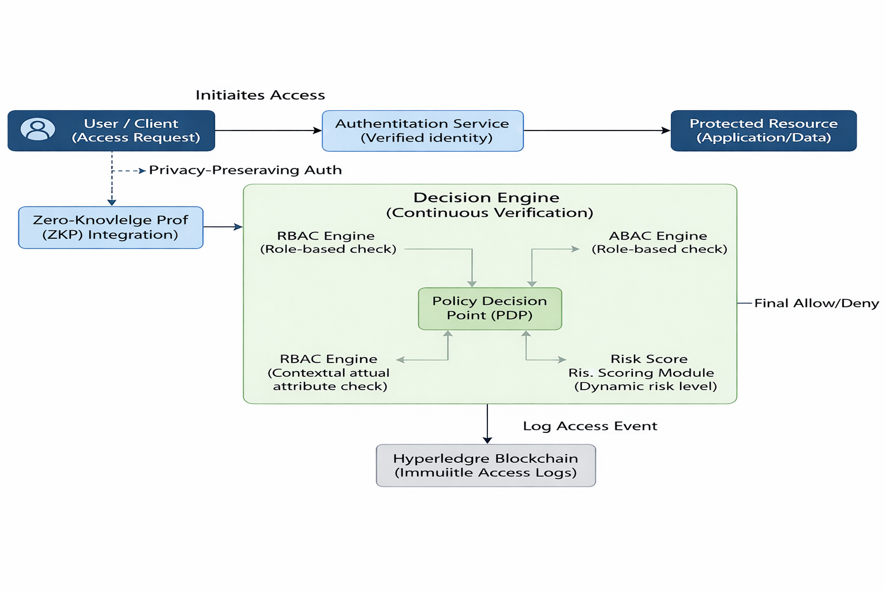
Fig 4.2: Proposed System Architecture

The architecture of the suggested system is based on a layered approach to Zero Trust, whereby all access requests will be subjected to authentication, authorization, risk assessment, and logging prior to accessing any resource in the system. This architecture is composed of several layers such as the user interface layer, application layer, security verification layer, and storage layer.
In the highest level of the architecture, there is the User Interface layer where users get to interact with the system through a web-based interface. Through this layer, users are able to register themselves and also authenticate before requesting access to resources.
Application Layer performs the essential functions associated with processing user requests. As soon as a request comes in, it gets intercepted by the Zero Trust Gateway. This is where all system requests enter, and no request can proceed without being verified by this layer first.
The request is subsequently routed to the Authentication module in which the identity of the user is verified through a privacy preserving authentication scheme that makes use of ZKP. After authentication of the user, the system gathers context information about the request, including trust levels of the device, time of access, and resource being requested.
Then, the request is forwarded to the authorization layer that includes Role Based Access Control (RBAC) and Attribute Based Access Control (ABAC). The function of RBAC module is to determine if the role assigned to the user allows access to the requested resource, and that of ABAC is to evaluate contextual attributes.
After carrying out the authorization checks, risk evaluation is carried out using the Risk Evaluation Module. This involves computing the dynamic risk score depending on the context, such as abnormal logging times, repeat accesses, or untrusted device accesses.
The results of the authentication process, RBAC, ABAC, and risk evaluation processes are then passed to the Decision Engine module. The engine analyzes the results to determine whether the access should be authorized, refused, or re-verified.
All access events, regardless of whether access was authorized or refused, are logged using the Blockchain Audit Logging Module. In this module, the logs are stored using a blockchain technology that ensures that the logs are immutable and cannot be altered.
In case the request for access was authorized, the resource will be provided to the resource consumer using the Resource Server. Otherwise, the access request will be refused and logged as well.

CHAPTER 5

SYSTEM IMPLEMENTATION

The design of the proposed Zero Trust Security Framework uses a modular approach with web-based applications incorporating different forms of security features like authentication, access controls, risk assessment, and blockchain audit logging. Each module plays a critical role in ensuring security with distinct security roles and interaction with others via the back-end server.

5.1.Frontend Implementation
The frontend of the system is built using advanced web technologies like React.js, HTML, CSS, and JavaScript. The frontend gives a dynamic interface to the users for registration, login, and requesting access to the system resources. The user's request is then sent to the backend server via secure API calls from the frontend. The frontend interface also shows the access results, whether access is granted or denied according to the backend response.
Algorithm: Frontend Request Handling
Step 1: The user provides their login credentials.
Step 2: Login credentials are forwarded to the backend API (/login).
Step 3: Authentication response received.
Step 4: If authentication is successful, session token stored.
Step 5: User chooses a resource and initiates access request (/access).
Step 6: Access is approved or denied or conditional.
Step 7: Response and calculated risk score is provided to the user.

5.2.Backend Implementation
The backend server has been developed with the help of Node.js with Express.js, wherein the latter serves as the primary processing unit. The backend receives input from the frontend and executes them by applying different security modules. These include the management of authentication, access control check, risk analysis, and database and blockchain logging.
Data regarding users, roles, and attributes are stored within a database, like MongoDB, so that all user data can be retrieved and processed for authorization checks.
Algorithm: Backend Processing Flow
Input: Request for access (user, resource)
Step 1: Input received from frontend
Step 2: Session verification of the user
Step 3: User information and attributes retrieval from database
Step 4: RBAC authorization
Step 5: ABAC authorization
Step 6: Risk calculation
Step 7: Decision engine
Step 8: Recording result on blockchain
Step 9: Output result to frontend

5.3.Authentication Implementation
The user authentication process is accomplished through the use of an authentication system that employs a privacy-friendly approach based on the Zero Knowledge Proof (ZKP). In the user authentication process, the user identity is verified using the challenge-response protocol rather than having the credentials stored. After successful verification, a session token is issued for the user to access the system.
Algorithm: ZKP-Inspired Authentication
Inputs: Username, Password
Step 1: The user sends username to the server
Step 2: The server creates a random nonce
Step 3: The server sends nonce to the user
Step 4: The user calculates hash(password + nonce)
Step 5: The user sends the hash to the server
Step 6: The server calculates the hash using the password hash
Step 7: Comparison of both hashes
Step 8:
If matches, Authentication is SUCCESSFUL
Otherwise, Authentication is FAILED
Step 9: Session Token Generation

5.4.Access Control Implementation
Role-Based Access Control and Attribute-Based Access Control are used for authorization purposes.
Role-Based Access Control is the method by which roles are assigned to users based on their status as an administrator or normal user. These roles will have certain permissions set by default.
Attribute-Based Access Control considers several factors, including the level of trust of the device being used, the access time, and the type of request made by the user.
Algorithm: RBAC Check
Input: User role, Requested resource
Step 1: Retrieve role permissions
Step 2: Check if resource exists in role permissions

Step 3:
If yes → RBAC = TRUE
Else → RBAC = FALSE

Algorithm: ABAC Evaluation

Input: User Attributes, Resource Policy

Step 1: Obtain user attributes (e.g., department, device, location)

Step 2: Obtain resource policy conditions

Step 3: Match user attributes with resource policy conditions

Step 4:

If conditions met → ABAC = TRUE

Otherwise → ABAC = FALSE

5.5.Risk Evaluation Implementation
The system is equipped with a risk assessment engine that assesses contextual data corresponding to each transaction. The risk factor is determined depending on whether the transaction is made at an odd hour, has multiple attempts, or uses unknown devices. Depending on the risk rating (low, moderate, or high), the system will decide whether to allow, limit, or block the transaction.
Risk Model Representation:
Risk Score = Σ (Weight × Risk Factor)
Example:
Unknown device → +30
Remote location → +20
Odd time → +15
High sensitivity resource → +25

Algorithm: Risk Scoring Model
Input: User context (device, location, time, resource sensitivity)
Initialize risk_score = 0
Step 1: If device == "unknown"
risk_score += 30
Step 2: If location == "remote"
risk_score += 20
Step 3: If access_time == "odd"
risk_score += 15
Step 4: If resource_sensitivity == "high"
risk_score += 25
Step 5: Return risk_score

5.6 Decision Engine Implementation
The decision engine computes the output from the steps performed during the authentication process, the RBAC authorization process, the ABAC evaluation process, and the risk scoring process. With respect to predetermined security policies, the decision engine comes up with the final decision on whether access should be granted or not.
Algorithm: Decision Engine
Input: RBAC_result, ABAC_result, risk_score
Step 1: If RBAC_result == FALSE
Decision = DENY
Step 2: Else if ABAC_result == FALSE
Decision = DENY
Step 3: Else
If risk_score < 30
Decision = ALLOW
Else if 30 ≤ risk_score < 60
Decision = CONDITIONAL
Else
Decision = DENY
Step 4: Return Decision

5.7.Blockchain Audit Logging Implementation
For purposes of transparency and tampering proof, all access attempts will be logged in an audit logging module using blockchain technology. The logs will include a hash of the user identification, requested resource, decision outcome, and time stamp. Since the logs are on a blockchain, they are tamperproof and unalterable after creation.
This system design will achieve a Zero Trust security architecture, where the identity of the user is verified at all times, stringent access policies are enforced, contextual risk assessment is carried out, and access requests are logged.
Algorithm: Block Creation
Input: Access decision data
Step 1: Retrieve previous block hash
Step 2: Create new block with:
index
timestamp
user (hashed)
resource
decision
risk_score
previous_hash
Step 3: Compute current_hash = hash(block_data)
Step 4: Append block to chain
Algorithm: Blockchain Validation
Step 1: For each block in chain:
Step 2: Compare stored previous_hash with actual hash of previous block
Step 3:
If mismatch → Chain tampered
Else → Continue
Step 4: If all valid → Chain is secure
By combining all the elements mentioned above, the system is able to successfully implement the Zero Trust approach through verifying the access requests, implementing hybrid access control strategies, assessing the contextual risk through a rule-based mechanism, and ensuring an unalterable audit trail.

CHAPTER 6

EXPERIMENTAL RESULT

The suggested Zero Trust Security Framework will be assessed to determine its ability to ensure access control security, detect any risk factors, and provide secure audit logging. The assessment will evaluate the system's performance in ensuring continuous authentication and preventing any unauthorized access.

6.1.Access Control Accuracy
The system was assessed through the testing of several scenarios of user interactions with respect to different kinds of users’ attributes. In all, 20 access attempts were tested, where 10 of the access attempts were successful, while another 10 were unsuccessful. The assessment shows that the access attempts made by unauthorized users have declined while those that have been authorized succeeded in accessing system assets. Overall, this achieved a success rate of about 90%.
Table 6.1: Access Control Results
Category | Total Cases | Correct Decisions | Accuracy
Authorized Access | 10 | 9 | 90%
Unauthorized Access | 10 | 9 | 90%
Overall | 20 | 18 | 90%
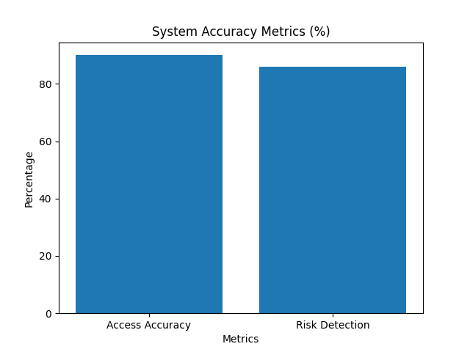
Fig: 6.1
This shows that the RBAC + ABAC model provides reliable access decisions.

6.2.Risk Detection Capability
The risk assessment engine was validated through the simulation of various access conditions, including odd login times, accessing using an unrecognized device, and location discrepancies. Altogether, 15 scenarios that were considered high risks were simulated. The system accurately detected 13 out of 15 cases to be high-risk, limiting or denying their access, with a success rate of roughly 86 percent.
Table 6.2: Risk Detection Results
Scenario Type | Total Cases | Correctly Detected | Detection Rate
High Risk | 15 | 13 | 86%

This shows that the rule-based risk model effectively identifies abnormal conditions.

6.3.Continuous Verification Performance
Continuous verification is achieved using the proposed system through the continuous assessment of access requests rather than single instance authentication. Consecutive requests for access were made by a user at various times and the average time taken for decision-making regarding these requests went up only slightly from 120 milliseconds in case of a normal authentication process to about 180 milliseconds with verification being performed.
Table 6.3: Response Time Comparison
Scenario | Avg Response Time (ms)
Basic Authentication | 120 ms
Zero Trust Verification | 180 ms
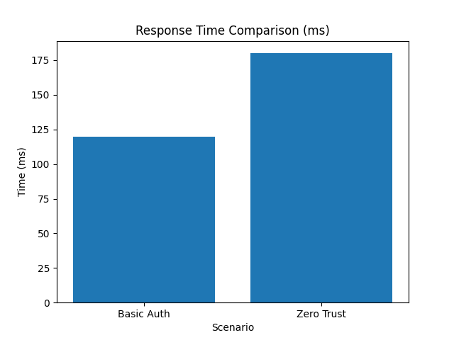
Fig: 6.2
This shows only a slight overhead (~60 ms).

6.4.Blockchain Audit Log Verification
The block-chain based audit logging mechanism is tested through ensuring the integrity of logged data. In order to generate each block, there is always a new decision generated along with a timestamp and the hash of the previously linked block. An experiment of manual manipulation of a log was carried out, which led to hash mismatching, thus breaking the chain consistency.
Table 6.4: Audit Log Integrity Test
Test Case | Result
Normal Logging | Valid Chain
Tampering Attempt | Hash Mismatch Detected
Chain Validation | Failed (Tampered)

This confirms the system is tamper-evident.

6.5.System Performance
Performance of the whole system is assessed through the measurement of the processing time of access requests under various conditions. In all cases, the system handled authentication, policies' checking, risk assessment, and logging processes in the time range of 150 ms - 250 ms on average. Based on these findings, we can conclude that usage of several security mechanisms together does not affect system performance negatively.
Table 6.5: Overall System Performance
Metric | Value Range
Average Response Time | 150–250 ms
Authentication Time | ~50 ms
Policy Evaluation Time | ~70 ms
Logging Time | ~30 ms

This shows the system performs efficiently under integrated security checks.

6.6.Security Effectiveness
This evaluation clearly shows that the system is able to implement the "never trust, always verify" philosophy of Zero Trust Architecture. With the use of authentication, hybrid access control, risk assessment, and auditing via blockchain technology, the architecture ensures a robust access control framework. From the evaluation findings, it can be noted that the access control system performs satisfactorily in ensuring proper access control.

CHAPTER 7

CONCLUSION

This work involves developing a Zero Trust Security Framework, which helps overcome the shortcomings associated with conventional perimeter security systems. The concept of "never trust, always verify" is employed, ensuring that authentication and verification are carried out for each access request in order to allow access to resources. Incorporation of authentication, RBAC, ABAC, and context-based evaluation allows the Zero Trust framework to authenticate and authorize access requests effectively and accurately.
Moreover, the use of blockchain technology allows auditing and maintaining a tamper-proof log of all accesses made to system resources. Results show that the proposed security framework increases access control accuracy and risky access detection while ensuring good system performance.
In general, the proposed system offers an adequate security solution for distributed networked environments that cannot rely on conventional security paradigms.

BIBLIOGRAPHY
[1] Rose, S., Borchert, O., Mitchell, S., & Connelly, S. (2020). Zero Trust Architecture. NIST Special Publication 800-207. National Institute of Standards and Technology.
[2] Goldwasser, S., Micali, S., & Rackoff, C. (1989). The Knowledge Complexity of Interactive Proof Systems. SIAM Journal on Computing, 18(1), 186–208.
[3] Liu, F. T., Ting, K. M., & Zhou, Z.-H. (2008). Isolation Forest. Proceedings of the 8th IEEE International Conference on Data Mining (ICDM), Pisa, Italy (pp. 413–422).
[4] Lewis, P., Perez, E., Piktus, A., Petroni, F., Karpukhin, V., Goyal, N., Küttler, H., Lewis, M., Yih, W., Rocktäschel, T., Riedel, S., & Kiela, D. (2020). Retrieval-Augmented Generation for Knowledge-Intensive NLP Tasks. In Advances in Neural Information Processing Systems (NeurIPS), 33, 9459–9474.
[5] Li, Y., Bubeck, S., Eldan, R., Del Giorno, A., Gunasekar, S., & Lee, Y. T. (2023). Textbooks Are All You Need II: phi-1.5 Technical Report. arXiv preprint arXiv:2309.05463.
[6] Vaswani, A., Shazeer, N., Parmar, N., Uszkoreit, J., Jones, L., Gomez, A. N., Kaiser, Ł., & Polosukhin, I. (2017). Attention Is All You Need. In Advances in Neural Information Processing Systems (NeurIPS) (pp. 5998–6008).
[7] Bhattacharya, S., Seth, D., Panyam, S., & Gangrade, P. (2024). Enhancing Digital Privacy: The Application of Zero-Knowledge Proofs in Authentication Systems. International Journal of Computer Trends and Technology, 72(7), 48–56.
[8] Chen, Z. (2023). A Survey on Zero-Knowledge Authentication for the Internet of Things. Electronics, 12(5), 1145.
[9] Pathak, A., Patil, T., et al. (2021). Bibliometric Survey on Zero-Knowledge Proof for Authentication. Library Philosophy and Practice (e-journal), University of Nebraska–Lincoln.
[10] ISO/IEC 27001:2022. (2022). Information Security, Cybersecurity and Privacy Protection — Information Security Management Systems — Requirements. International Organization for Standardization.

[11] Khan, M. A., Shanker, V., Karovalia, I., Shaikh, H. A., & Jha, A. (2025). Zero-Trust Security Architecture Enhanced by Machine Learning in Blockchain Healthcare Systems. ResearchGate Preprint.
[12] Gupta, R., & Kumar, S. (2025). A Zero-Trust AI-Blockchain Architecture for Quantum-Secure Metaverse Platforms. ResearchGate Preprint.
[13] Li, J., Wang, X., & Zhang, Y. (2025). A Systematic Literature Review on the Implementation and Challenges of Zero Trust Architecture Across Domains. PLOS ONE, 20(2), e0312988.
[14] Gopireddy, S. R. (2025). Implementing Zero-Knowledge Proofs for Enhanced Security in Cloud Authentication Systems. ResearchGate Preprint.
[15] Ammann, N., et al. (2024). Security and Vulnerabilities of Retrieval-Augmented Generation: A Systematic Review. alphaXiv Preprint.
[16] Brown, D., et al. (2024). RAG Techniques, Metrics, and Challenges: A Systematic Literature Review. Information (MDPI).
[17] Kumar, R., & Sharma, P. (2024). Zero-Trust Security Architecture in the AI Era: A Novel Framework for Enterprise Cyber Resilience. International Journal of Scientific Research and Analysis, 3(4), 112–125.
[18] Nakamoto, S. (2008). Bitcoin: A Peer-to-Peer Electronic Cash System. White Paper.
[19] Merkle, R. C. (1988). A Digital Signature Based on a Conventional Encryption Function. In Advances in Cryptology — CRYPTO '87 (pp. 369–378).
[20] NIST. (2001). Advanced Encryption Standard (AES). Federal Information Processing Standards Publication 197. National Institute of Standards and Technology.

APPENDIX
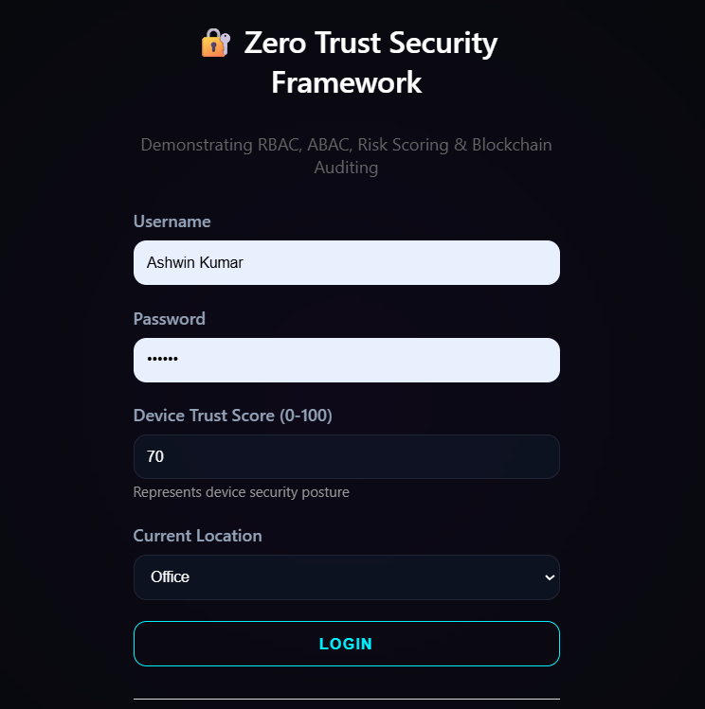
Appendix 1
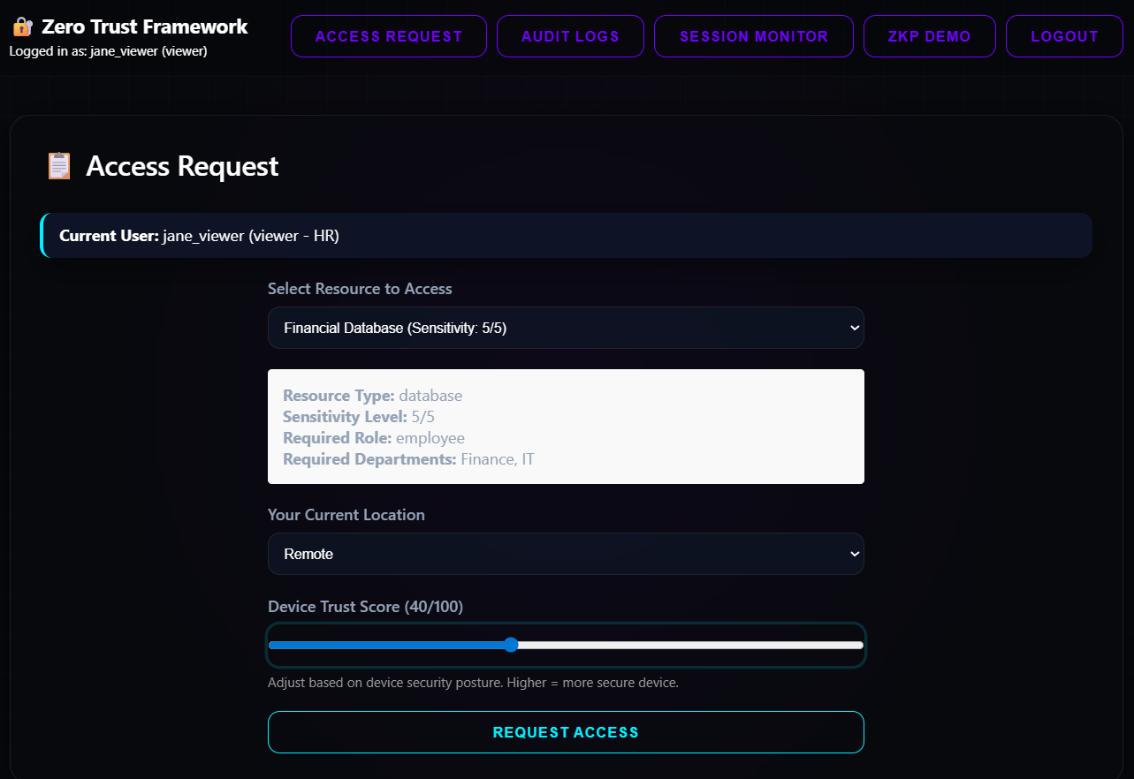
Appendix 2
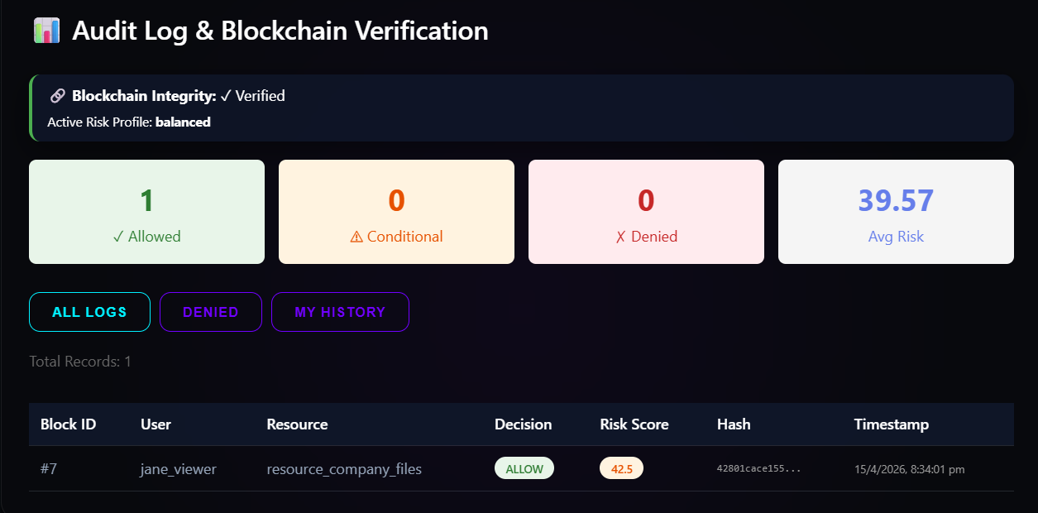
Appendix 3
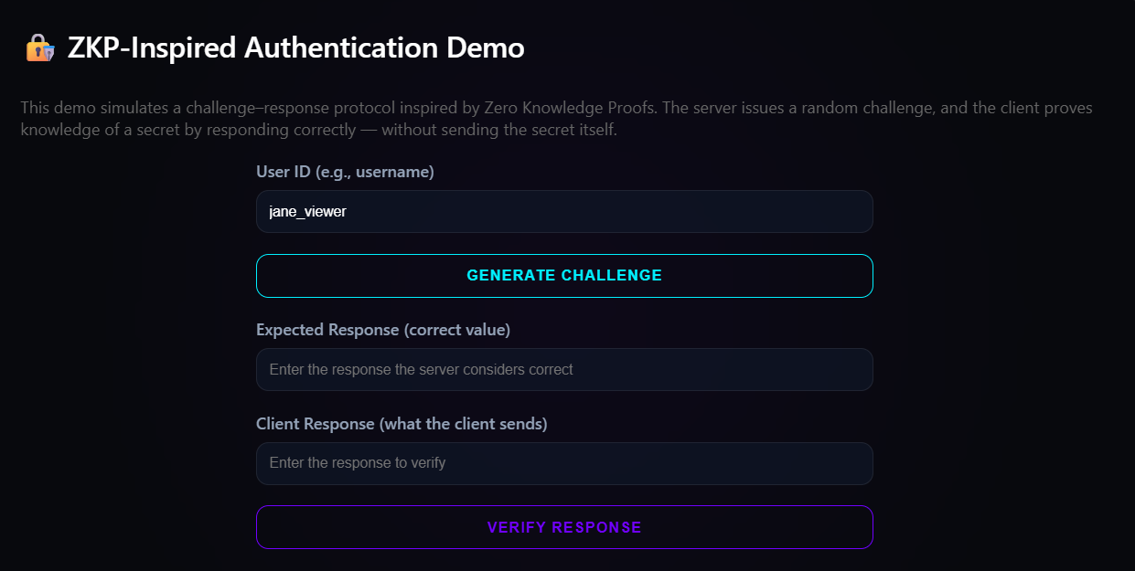
Appendix 4

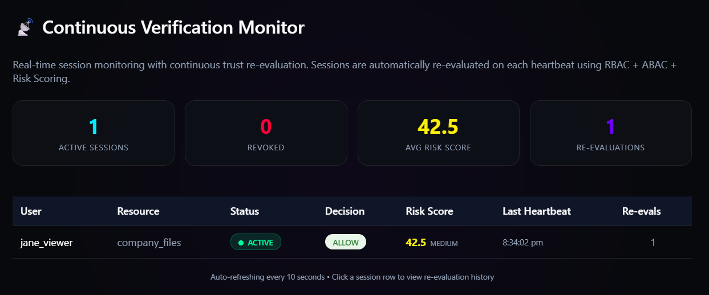
Appendix 5

